NAME: _______________________________________________ DATE: _____________________

2.3-1 Applying Newton’s Laws of Motion

Practice Questions
1. Two people pull on ropes as illustrated below:

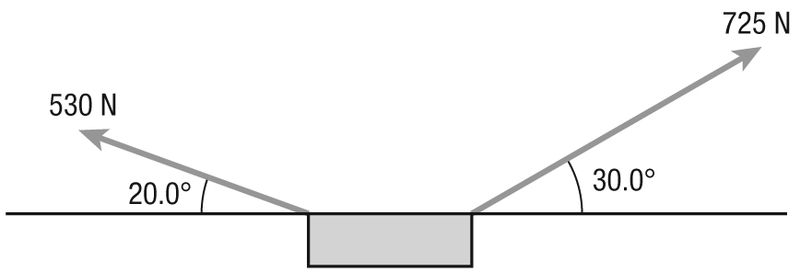

Find the mass of the object if the forces applied cause the object to just lift off of the ground.

2. A 1250 kg car is towing a 2160 kg truck using a rope to connect the two vehicles. The acceleration after being stopped at a red light is 1.10 m/s² forward once the light turns green.
(a) Find the force needed to accelerate the connected vehicles.

(b) What minimum strength needed in the rope connecting the two vehicles?

NAME: _______________________________________________ DATE: _____________________

2.3-1 Applying Newton’s Laws of Motion (continued)

3. A boy on a toboggan is sliding down a hill that makes an angle θ to the horizontal. The height of the hill is 34 m.
(a) What will be the speed of the toboggan at the bottom of the hill?

(b) Explain why the answer to part (a) does not require the angle of the hill or the mass of the toboggan and boy.

4. An 8.50 kg mass and a 17.0 kg mass are connected by a string over a pulley as shown in the figure below:

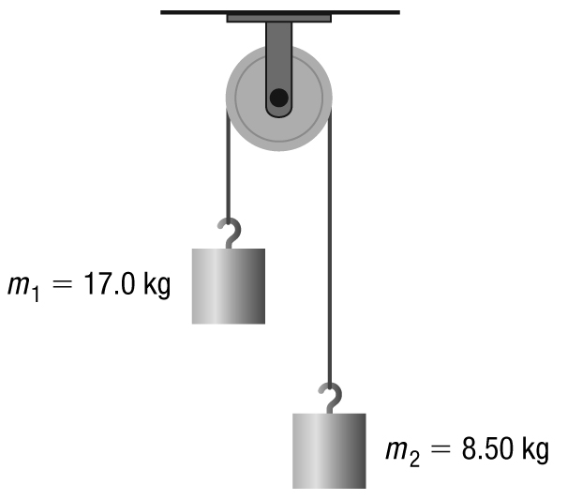

(a) Calculate the acceleration of the system.

(b) Calculate the tension in the string that connects the two masses.

